Battle of Monmouth Program
Student/Classroom Version
Purpose of Program:
Preparation for Program:
- Colored paper for paper hats. For up to 30 students in a class, you will need:
Color | Quantity | Text
Red | 15 | (None)
Blue | 15 | (None)
Brown | 5-7 | New York  Philadelphia  Monmouth Courthouse
- Crossword Puzzles with Admission Coupons
- Tan Battle of Monmouth Maps
- Battle of Monmouth Trunk
- 4 wooden muskets
- Teacher Evaluation Form – one for each teacher if multiple programs are given on a single day.
- March Across NJ map

In the classroom:
- Set up trunk contents on a table.
- Put up map on a board with magnets or hooks.

- Introduction and Curtsy/Bow: (3 minutes)
  - Introduce yourself and your assistant, if you have one. “Hello, students! We are [insert name(s)] from Monmouth County Historical Association. Let me tell you about us for a minute. We own five historic houses around Monmouth County and a museum in Freehold which holds rotating exhibitions. Today, we are here to talk about the Battle of Monmouth, which happened on Sunday, June 28, 1778.”
  - “Let’s get you into the 18th century mindset a bit by showing you students how people greeted each other on the street.” Select two students to join you at the front of the room. Show the children how men and women of the 1700s would greet each other.
    - No touching or shaking hands.
    - Men: Left foot forward, right hand behind the back, grab the front of your hat with your left hand and bow while removing the hat. “Good morning, miss.”
    - Women: Left foot forward like in a ballet position, hands holding the sides of your skirt. Bend at the knee and slightly bow your head. A curtsy. “Good morning, sir.”

- Leading up to the Revolutionary War: (10 minutes)
  - Taxes/Acts Created by King George III – after each act/tax, ask how the students feel. They should begin to be frustrated, feel bullied, mad, etc.
    - King George III needed money to pay down the debt from the war. Parliament implemented taxes in the colonies.
    - The Quartering Act: (Put on redcoat and find a desk you like. Cite the Quartering Act to remove the student from his seat.)
It's where a soldier could just come into your house and take it over.
    - The Stamp Act: (pass around the wrapped cards)
The Stamp Act was when all the paper had to have a particular stamp on it and after you pay for the paper, you have to pay a tax on the printed item, too.
    - The Sugar Act: (optional – because this doesn’t have a student activity associated with it.)
Enforcing the tax on sugar and molasses, plus added tax on other imported goods from England like calico cloth, rum, etc. Daily items needed by the colonists to live.
    - The Townsend Acts: (optional – because this doesn’t have a student activity associated with it.)
Created by Charles Townsend in Parliament, they imposed duties on glass, lead, paints, paper and tea imported into the colonies. Again, daily items needed by the colonists to live.
  - Declaration of Independence and Choosing Sides
(Pass out the colored papers evenly distributing the “Patriot/Blue”, and the “Loyalist/Red” papers, and scatter 5-6 “Neutralist/Brown” papers.)
    - About the Declaration of Independence: “All men are created equal”. Explain that this means that King George is equal to a common man in the eyes of the government.
(Notes: Traditionally, England had a class system, where the king was chosen by God, and therefore was above the commoners. His say had a greater weight than the commoners, even though he had to answer to Parliament. The concept that his vote had the same weight as Bob the Cobbler’s vote was outrageous!)
    - Choosing a side: Tell the students that some colonists were Patriots, others were Loyalists, and some were Neutralists. It was a hard decision for many – no one was wrong. Ask for their thoughts.
    - Boston conflicts – Boston Massacre, Boston Tea Party, Lexington & Concord
    - Washington was made the general of Continental Army. Washington didn't sign the Declaration of Independence because he was not in Philadelphia – he was the head of Continental Army at that point.

- Leading up to the Battle of Monmouth (15 mins)
  - At this point in history, the Revolutionary War has been active for almost 2 years. In New York, New Jersey, and Pennsylvania - there were two major situations going on:
    - Washington was in a bit of a bind. He was made the Commander-in-chief but he wasn’t without his critics because of his lackluster battle results. His critics within Congress wanted to replace him with Charles Lee or Horatio Gates. He needed success in battle to solidify his position as the head of the Continental Army. He wanted to keep his job, so he set off from Valley Forge where the men trained over the winter of 1777. His objective was to show Congress that he was a great leader and validate his position as the Commander-in-chief.
To set the stage for the scene: BRIEF discussion of Washington at Valley Forge where the troops trained under von Steuben to become professional soldiers. (2 mins max). The conversation can be similar to this:
“Washington needed more professionally, formerly trained troops, not as many local minute men/local militia groups. When Ben Franklin was in France, he met Baron von Steuben – a Prussian officer, who came to Valley Forge to help train the continental soldiers.
He spoke German and a bit of French. His assistant spoke French and a little English. The troops spoke no German and very little French! Translation was tricky.
So for our demonstration of what being a soldier was like at Valley Forge, I need two assistants. (randomly select two students) You and you will do…as long as you have all your teeth.”
Dress the Soldiers:
First, the coats and cocked hats are given to the participants. Next, the wooden fife is given to the participant wearing the red coat. It is explained that that person is the musician. [Insert why musician was important on field.] Next, the presenter selects one item from the table and asks the audience what they think the item is. Only 2-3 tries are given before the presenter moves on to the discussion about that item. This continues until each soldier has a fairly equal amount of items in their haversacks. The items that are used in this are:
- Blue/red coats
- Cocked hat
- Wooden fife
- Haversacks
- Cartridge case – good place to explain the need for teeth. A soldier’s teeth were used to rip off the top part of the paper on the cartridge. See diagram below for details.
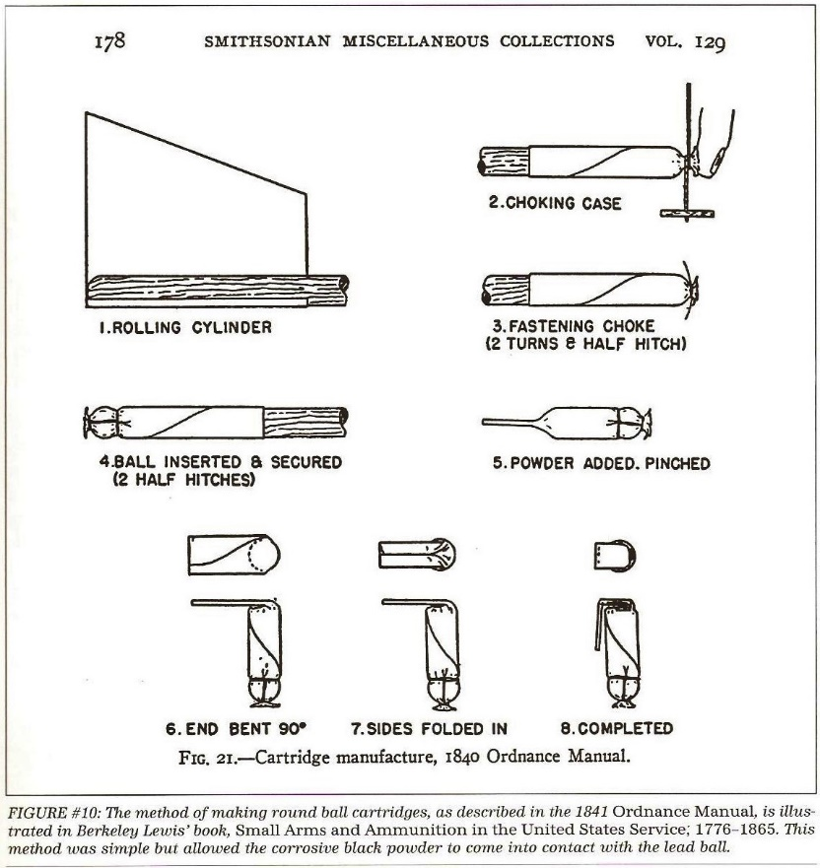
- Musket baller and musket balls
- Canteens – one wooden – made by a cooper, one tin – made by a whitesmith or tinsmith
- Plate and bowl – made from treenware (of the tree). Hard to break, easy to replace.
- Utensils
- Cups – horn and tin
- Flint and steel holder
- Cards and dice – for spending leisure time.
- Wallet
- Spectacles

For Student Program - Marching Drill: After the participants are dressed as soldiers, two to four more participants are selected from audience. All are given wooden muskets and shown how it may have been like to have von Steuben training the soldiers at Valley Forge since he spoke in German and there was a great deal of translating into English. When done, thank the participants and they take their seats.

Thank the students for their participation and they remove gear and sit down.

    - At the same time, the British decide to leave Philadelphia and concentrate their resources - all their provisions, munitions, personal baggage, etc. - in NYC. The French fleet was on its way from France and it wasn’t known when it was going to arrive. The British knew they couldn’t protect both locations, so it was decided to abandon Philadelphia and take all the provisions and head to NYC. Their objective was to make it to Sandy Hook Bay with the wagon train intact.
  - March across NJ, Timeframe: May into June 1778 (about 30 mins into program)
    - The British need to get from Philadelphia to NYC. This can be done over land or sea. Going by sea means that the ships sail down the Delaware and into the Delaware Bay at the bottom of NJ, up to NY/Sandy Hook Bay. The British didn’t want all of the troops to go by sea because there could be a bottleneck at the base of NJ if the French fleet blocked them in the Delaware Bay. They didn’t have enough navy vessels to take everyone and all their provisions, equipment, etc., by sea, so a portion went by land, also.
    - Sir Henry Clinton leaves Philadelphia in the spring of 1778 with a wagon train of 1,500 wagons that was about 10 miles long and couldn't go very fast due to the weather and road conditions. The summer was unbearably hot and the troops on both sides traveled carrying as little as possible.
To demonstrate the distance and the wagon train length, bring up the following:
- The “NY Brown Hat” – that student stands in a front corner of the room.
- The “Philadelphia Brown Hat” – put student in back corner of room
- The “Monmouth Courthouse Brown Hat” – put this student in the middle of the classroom between the other two students.
- Bring up two or three more Brown Hats and three Red Hats and three Blue Hats.
- Place the Brown and Red Hats as follows: Red, Brown, Red, Brown, and Red. This represents the British Front Troops, wagons, more British troops, wagons, the British Rear Guard.
- The Blue Hats will be behind the British wagon train. The wagon train is to walk veeeeeeery slowly from Philadelphia to Monmouth Courthouse with the Patriots following behind. The “Wagon Train” stops on the “New York” side of “Monmouth Courthouse”.

    - The British FINALLY reach Monmouth Courthouse (have the students stop there with the Patriots hanging out behind them. On June 26, 1778, General Clinton took over Mrs. Elizabeth Covenhoven's house to stay while he was in Freehold, formerly known as Monmouth Courthouse. He throws Mrs. Covenhoven, a 74-year-old woman, in the cellar and locks her there overnight. He stays for 3 days.
(Note: Mention that the house still stands and can be visited during the summer.)

- Battle of Monmouth (20-25 mins)
Set the scene:
- Both armies are right outside of Freehold/Monmouth Courthouse. The Continental Army is at Englishtown and Manalapan. The British troops are just to the east of town plus General Clinton is staying at Covenhoven House.
- It’s HOT!!!!! High humidity, billions of mosquitos.
- Communication between units was very difficult.
- The battle takes place on a Sunday, which was very unusual. Sunday is traditionally a day of rest.
- At this point, the students – except for “New York” and “Philadelphia” are at “Monmouth Courthouse”. The “Wagon Train” students can stand on the side of “Monmouth Courthouse” nearer to “New York”.

For students’ narrative:
- Early in the morning on June 28, 1778, Charles Lee – who was Washington’s second in command – took about 5,000 troops to attack the soldiers at the end of the British wagon train. He thought he was going up against around 1,500 British soldiers. In reality, he is greatly outnumbered. He pulled the troops back away from the British to regroup and find a better position to defend themselves.
- Washington, on his way in from having a leisurely breakfast in Englishtown, runs into Gen. Lee retreating from the British. He’s not happy with his second in command at all and words are exchanged. Lee is basically put in time-out for retreating.
- All day long, there are small skirmishes all over the battle field. No big confrontation between the two armies. Until…..
- About 1:30 in the afternoon. The British have brought out the Big Guns – 6- and 12-lb cannons plus howitzers. What’s called “The Great Cannonade” has begun!!! For the next 2 hours, the Continental troops are returning fire onto the British. Neither side is making any headway – no movement going back and forth. No one is getting the upper hand in the fight.
- While this is going on, one of Washington’s generals, Nathaneal Green, brings his cannons to the top of Combs Hill – where the visitor’s center is located at Monmouth Battlefield. By doing that, the British troops are covered on three sides by Continental troops. Green starts firing his cannons on the British!!! The heavy bombardment continues for 15 minutes before Gen Clinton decides to move his troops away from the cannon fire.
(Position the Red Hats in one spot and surround them on three sides with three Blue Hats.)
- The British troops continue to move away, back towards their encampment. The fighting dies down and a few Continental troops continue to harass the British, but it doesn’t amount to anything.
(Send the Red Hats and Wagon Train to New York.)
Cannonball: When discussing the artillery portion of the Battle of Monmouth, the cannon ball is passed around the audience to feel how heavy it is.
Molly Pitcher: Both sides had “support staff” known as “campfollowers” – a group of women who supported the soldiers by doing their laundry, cooking, baking, etc. Some of these women would help out on the battlefield by bringing water to the soldiers and cannons. You may have heard of a woman from the Battle of Monmouth – she is known by the name Molly Pitcher, but it wasn’t her real name. Select a student to be Molly Pitcher and give them the cap, apron, and pail. “Molly” was a nickname for all the female campfollowers. The men would shout “Molly! Pitcher!” and that became her name. We believe her to be Mary Hayes from Carlisle, PA. Because the heat was so intense on the day of the battle, soldiers were dropping from heat exhaustion.
  - Washington’s forces continue their harassment while the British troops are withdrawing. Finally in the evening, the fighting stops on both sides. The Continental Army camps overnight, expecting to resume fighting in the morning.
  - The next day on June 29, 1778:
    - Continental side:
Washington’s men woke up the next day to resume the fighting and realized that the British troops and wagon train were nowhere to be found. British Col. Monkton’s body was found on the battlefield along with his sword, which we now have in our collection.
    - British side:
June 28-29: By 11pm on the day of the battle, British General Knyphausen, who is in charge of the wagon train, starts the wagon train traveling towards Highlands and Sandy Hook Bay. Monmouth and Middlesex militia harass the troops, but are pushed away. They make it to Nut Swamp – 3 miles outside of Middletown by sunset the next day, June 29, with stragglers coming in by dawn the next day.

- Conclusion (5 mins)
  - So who won? Each side obtained their goals:
  - Washington kept his job in part because of this successful campaign.
  - The British went on to NYC with their provisions on the wagon train intact.
  - The battle was important for the Continental Army as the British were out of New Jersey. It showed that the Continental Army could stand up to the British Army in battle.
  - It was the last Northern land battle of the American Revolution.

If there is time, you can mention the King George statue that was erected in Bowling Green, NYC.
If there’s time, the King George statue in Bowling Green, NYC, was torn down by enraged colonists on July 9, 1776, when the Declaration of Independence was read. It turns out that it was made out of gold-covered lead and most of the lead was used by Patriots to make musket balls during the war. 42,000 of them.
These troops are called “the rear guard” because they are at the rear of the regiment line.
Mounted on a field carriage, a howitzer is like a canon and fired both bombs (mortars) and cannon balls at a flat or high trajectory.

