PRIMARY SOURCE WORKSHOP Student Worksheet

Archival Documents
- First consider the type of record this is. Look at the wording carefully. How do you think John Taylor viewed the birth of Matilda? How might Clarisse have felt about Matilda's birth?​ Explain your reasoning.

- Why might John have replaced the word "girl" with "female" instead?

- This is a farm inventory listing Samuel Taylor's property, including Ephraim. What information does it give you, and what can it tell you?

- What does it say about Ephraim in the context of this record?

- What information does this manumission paper give us, and how can it help us piece together details?

- Although there are few facts about Hannah, what can we guess about what her life may
have been like?

- What were Hannah's options to support herself and her children after her manumission?

- What things are we still left to wonder about her?

- What do you notice about the terms of sale for Clarisse in comparison to those of
Matilda, and what is the reason for the difference in terms?

​10. What is a possible scenario for this mother and daughter if the terms of the agreement
are carried out as written?

11. While slavery and indentured servitude were different in length of time and
voluntary choice, in what ways are they similar?

12. Lewis signed on as an indentured servant to have the security of work, food, clothing
and shelter. Once Lewis was no longer "wanted," where did that leave him? What does
it say about his value as a person?

​13. What were the possible consequences for Lewis as a black man if he ventured far from
home and lost his travel pass?

Runaway Ads
Use this chart to extract the tracking information from the 18th and 19th century runaway ads. The effectiveness of these seemingly small notices will become apparent when you begin to piece the information together.

Time/ Location | Physical Details | Skills | Other

1. What stood out to you in these runaway ads? Did anything surprise you?

2. What information might we be left wondering about?

3. There were many reasons to run away. Can you think of anything that
might have prevented a person from doing so? (Hint: What might they
have been leaving behind, or what challenges might they face in leaving?)

Finish Their Story
Historically Accurate Creative Writing

These ads tell us that the person ran away, but nothing of the heart-pounding experience that followed. Sometimes we just don't have documentation to give us answers, but we can ask questions and use historical background knowledge to help form a possible scenario. Select an ad and write a short short narrative from the runaway’s perspective using the historically accurate information you have learned. In doing so, you are doing them the honor of remembering them as people with meaningful lives. Use the following prompts to help you:

1. Who was this person? Use adjectives to describe them (kind, smart, funny, quiet,
tough…)
2. What type of work did they do? (House, farm, mill, trade, etc.)
3. What made them decide to run away?
4. How did they escape? Was it day or night, and why did they choose that time?
5. What were they thinking and feeling as they ran away?
6. Where were they headed? (to the water, to another town or city...)
7. Did they have help or were they all alone?
8. What challenges did they face along the way?
9. Did they ultimately escape, or were they captured and returned? What happened
to them?

For Sale ads
Use this graphic organizer to document the “selling points” of humans in bondage in the sale ads. Write a small explanation of the benefits of each.
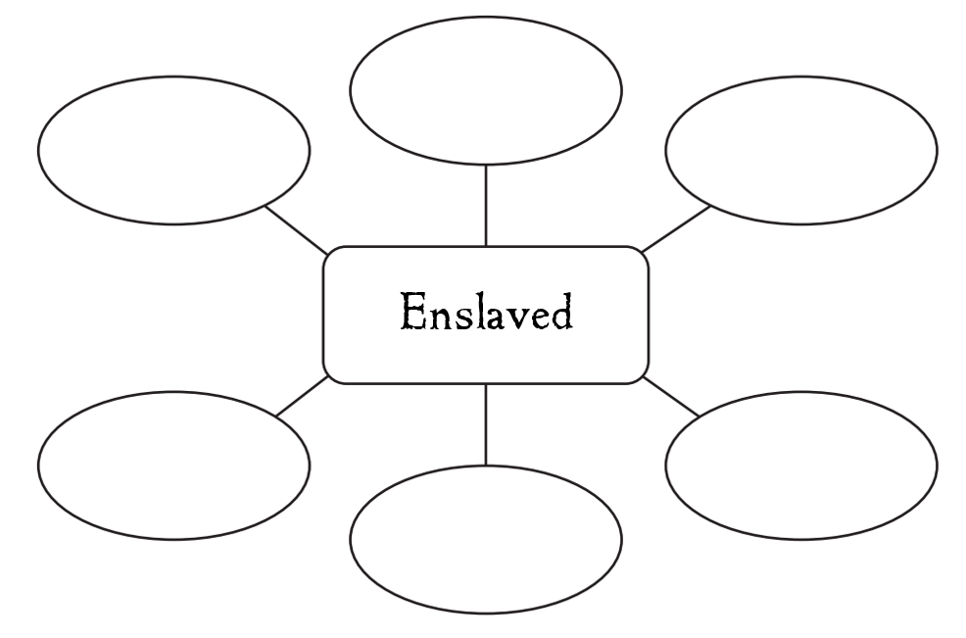
Enslaved:

- In ad #2, why might it be a selling point to note “country born?”

- Why might enslaved women with children be a selling point?

- Ad #5 regards the sale of a man and his wife. Is the purchaser under any obligation to keep the two together after they have been sold?

- In ad #6, we see the line, “has been used to wait on a table.” What does this type of language make you think of?

- In ad #9, the children are being sold because the owner does not have a need for them. Do we know who the children belong to? Does the ad specify that the children must be purchased together as a group?

- Why might it be important to note if the person for sale has had small pox and measles?

Deep Down in My Heart

- The song Wade in the Water contained secret information that could help the enslaved make a successful escape. Can you think of any other secret ways to convey messages?

- Listen to the clip of Swing Low Sweet Chariot and Deep Down in My Heart. How are they different? What is the purpose of each?

Analyzing Art

Image 1
- In the first image of the enslaved dancing, what elements do you see in the illustration, and why are they important?

Image 2
- What kind of educated guess can you make about what type of community this is? Are they free? Enslaved? Explain your answer.

- What day of the week is this image likely to represent? Why?

Image 3
- This image is called The Last Daughter. What do you think is happening in this scene? Is this a historically accurate depiction? Explain.

Image 4
- Describe the mood in this image. What is happening here? What details are you basing your answer on?

- Why is it unusual for such a large group to be traveling together, especially with a small child?

- The people portrayed are quite close to the water. Do you think this is intentional? Why or why not?

​Image 5

- In a paragraph or two, tell the story of what lies behind this woman’s sadness using historically accurate details.

